MOVE BAR 12x40

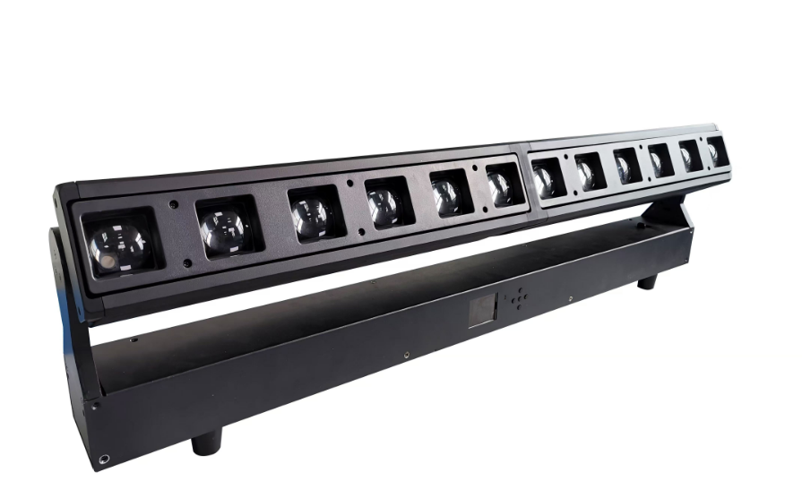

User Manual
KEEP THIS MANUAL FOR FUTURE NEEDS

Unpacking
Thank you for choosing 640Zoom Led Mover. For your own safety, please read this manual before installing the device. This manual covers the important information on installation and applications. Please install and operate the fixture with following instructions. Meanwhile, please keep this manual well for future needs.
LED740zoom is made of a new type of high temperature strength of engineering plastics and cast aluminum casing with nice outlook. The fixture is designed and manufactured strictly following CE standards, complying with international standard DMX512 protocol. It’s available independently controlled and linkable with each other for operation. And it is applicable for large-scale live performances, theater, studio, nightclubs and discos.
4-IN-1 LEDs(RGBW) which features high brightness and stability. Please carefully unpack it when you receive the fixture and check whether it is damaged during the transportation. And please check whether the following items are included inside the box:
Lamp---One，Signal Cable---One， Hanging Bracket----Two，Power Cable---One，User Manual---One

Specifications
Item number:ELB-6X40W
voltage AC100-240V 50/60Hz
LED S: 12 x 40W 4in1 RGBW LED
Average lifetime≥50000H
Each led can be controlled individually
Zooming angle 4°-37°
Control Mode: RDM,DMX512, Auto run, Master slave, Sound active
Dimmer: 0-100% Smooth linear LED dimmer
Display LCD display
Tilt 270°( 8bit/16bit precision scanning)
Color: Homogeneous RGBW macros color and,wonderful rainbow effect
Channel: 16CH/60CH
Power Connectors: Power connect Powercon in&out
DMX Connectors: 3-pin & 5-pin DMX input/output
Light Housing: Durable plastic composite housing
Strobe: Fast electric strobe 1 ~ 20 Hz
Packing Size: 112*19*38cm G:W:18.5KG

Maintenance and Cleaning
The following points have to be considered during the inspection:
- All screws for installing the devices or parts of the device have to be tightly connected and must not be corroded.
- There must not be any deformations on the housing, color lenses, fixations and installation spots (ceiling, suspension, trussing).
- Mechanically moved parts must not show any traces of wearing and must not rotate with unbalances.
- The electric power supply cables must not show any damage, material fatigue or sediments.
Further instructions depending on the installation spot and usage have to be adhered by a skilled installer and any safety problems have to be removed.

In order to make the lights in good condition and extend the life time, we suggest a regular cleaning to the lights.
- Clean the inside and outside lens each week to avoid the weakneness of the lights due to accumulation of dust.
- Clean the fan each week.
- A detailed electric check by approved electrical engineer each three month, make sure that the circuit contacts are in good condition, prevent the poor contact of circuit from overheating.
We recommend a frequent cleaning of the device. Please use a moist, lint- free cloth. Never use alcohol or solvents.There are no serviceable parts inside the device. Please refer to the instructions under “Installation instructions”.Should you need any spare parts, please order genuine parts from your local dealer.

Safety Instructions
This device has left the factory in perfect condition. In order to maintain this condition and to ensure a safe operation, it is absolutely necessary for the user to follow the safety instructions and warning notes written in this user manual.
If the device has been exposed to temperature changes due to environmental changes, do not switch it on immediately. The arising condensation could damage the device. Leave the device switched off until it has reached room
temperature.
This device falls under protection-class I. Therefore it is essential that the device be earthed. The electric connection must carry out by qualified person.
The device shall only be used with rate voltage and frequency.
Make sure that the available voltage is not higher than stated at the end of this manual.
Make sure the power cord is never crimped or damaged by sharp edges. If this would be the case, replacement of the cable must be done by an authorized dealer.
Always disconnect from the mains, when the device is not in use or before cleaning it. Only handle the power cord by the plug. Never pull out the plug by tugging the power cord.
During initial start-up some smoke or smell may arise. This is a normal process and does not necessarily mean that the device is defective, it should decrease gradually.
Please don't project the beam onto combustible substances.
Fixtures cannot be installed on combustible substances, keep more than 50cm distance with wall for smooth air flow, so there should be no shelter for fans and ventilation for heat radiation.
If the external flexible cable or cord of this luminaire is damaged, it shall be exclusively replaced by the manufacturer or his service agent or a similar qualified person in order to avoid a hazard.

Operation Instructions
-The moving head is for wash & Beam effect for on-site decoration purpose.
-Don’t turn on the fixture if it’s been through severe temperature difference like after transportation because it might damage the light due to the environment changes. So make sure to operate the fixture until it is in normal temperature.
-This light should be keep away from strong shaking during any transportation or movement.
-Don’t pull up the light by only the head, or it might cause damages to the mechanical parts.
-Don’t expose the fixture in overheat, moisture or environment with too much dust when installing it. And don’t lay any power cables on the floor. Or it might cause electronic shock to the people.
-Make sure the installation place is in good safety condition before installing the fixture.
-Make sure to put the safety chain and check whether the screws are screwed properly when installing the fixture.
-Make sure the lens are in good condition. It’s recommended to replace the units if there are any damages or severe scratch.
-Make sure the fixture is operated by qualified personnel who knows the fixture before using.
-Keep the original packages if any second shipment is needed.
-Don’t try to change the fixtures without any instruction by the manufacturer or the appointed repairing agencies.
-It is not in warranty range if there are any malfunctions from not following the user manual to operate or any illegal operation, like shock short circuit, electronic shock, lamp broke, etc.

DMX-512 control connections
Connect the provided XLR cable to the female 3-pin XLR output of your controller and the other side to the male 3-pin XLR input of the moving head. You can chain multiple
Moving heads be connected together through serial linking. The cable needed should be two core, screened cable with XLR input and output connectors. Please refer to the diagram below.
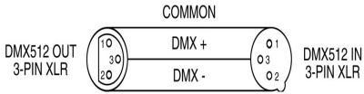
DMX-512 connection with DMX terminator
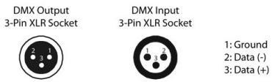

For installations where the DMX cable has to run a long distance or is in an electrically noisy environment, such as in a discotheque, it is recommended to use a DMX terminator. This helps in preventing corruption of the digital control signal by electrical noise. The DMX terminator is simply an XLR plug with a 120 Ω resistor connected between pins 2 and 3,which is then plugged into the output XLR socket of the last fixture in the chain. Please see illustrations below.
120Ω
2
3
1

PIN 3
PIN 2

Display chart
Address | 1-512
RUN | DMX512
RUN | Auto
RUN | Sound
DMX MODE | CH16
DMX MODE | CH60
TEST | ALL
SET |  | DISPLAY | No/Yes
 |  | Signal Keep | No/Yes
 |  | Slave | No/Yes
INFO | Version | Vx.xx
 | Tilt
 | ZOOM
MANUAL | Red
MANUAL | Green
MANUAL | Blue
MANUAL | Strobe
RESET | All Reset | No/Yes

DMX channel(16/60CH)
16CH | Function | DMX Value | Description
1 | Tilt | 0-255 | 0-100%
2 | Tilt Fine | 0-255 | 0-100%
3 | Zoom | 0-255 | 0-100%
4 | Dimmer | 0-255 | 0-100%
5 | Strobe | 0-19 | No Effect
5 | Strobe | 20-255 | Strobe slow to fast
6 | 1 Color Select | 0-10 | No Function
6 | 1 Color Select | 11-25 | Red
6 | 1 Color Select | 24-40 | Green
6 | 1 Color Select | 41-55 | Blue
6 | 1 Color Select | 56-70 | White
6 | 1 Color Select | 71-85 | R +G
6 | 1 Color Select | 86-100 | R+B
6 | 1 Color Select | 101-115 | G+B
6 | 1 Color Select | 116-130 | R+W
6 | 1 Color Select | 131-145 | G+W
6 | 1 Color Select | 146-160 | B+W
6 | 1 Color Select | 161-175 | R+G+W
6 | 1 Color Select | 176-190 | R+B+W
6 | 1 Color Select | 191-205 | G+B+W
6 | 1 Color Select | 206-255 | R+G+B+W
：
11 | 12 Color Select | 0-10 | No Function
11 | 12 Color Select | 11-25 | Red
11 | 12 Color Select | 24-40 | Green
11 | 12 Color Select | 41-55 | Blue
11 | 12 Color Select | 56-70 | White
11 | 12 Color Select | 71-85 | R +G
11 | 12 Color Select | 86-100 | R+B
11 | 12 Color Select | 101-115 | G+B
11 | 12 Color Select | 116-130 | R+W
11 | 12 Color Select | 131-145 | G+W
11 | 12 Color Select | 146-160 | B+W
11 | 12 Color Select | 161-175 | R+G+W
11 | 12 Color Select | 176-190 | R+B+W
11 | 12 Color Select | 191-205 | G+B+W
11 | 12 Color Select | 206-255 | R+G+B+W
12 | Background Dimmer | 0-255 | 0-100%
13 | Show | 0-10 | No Function
13 | Show | 11-15 | Show1
13 | Show | 16-20 | Show2
13 | Show | 21-25 | Show3
13 | Show | 26-30 | Show4
13 | Show | 31-35 | Show5
13 | Show | 36-40 | Show6
13 | Show | 41-45 | Show7
13 | Show | 46-50 | Show8
13 | Show | 51-55 | Show9
13 | Show | 56-60 | Show10
13 | Show | 61-65 | Show11
13 | Show | 66-70 | Show12
13 | Show | 71-75 | Show13
13 | Show | 76-80 | Show14
13 | Show | 81-85 | Show15
13 | Show | 86-90 | Show16
13 | Show | 91-95 | Show17
13 | Show | 96-100 | Show18
13 | Show | 101-105 | Show19
13 | Show | 106-110 | Show20
13 | Show | 111-115 | Show21
13 | Show | 116-120 | Show22
13 | Show | 121-125 | Show23
13 | Show | 126-130 | Show24
13 | Show | 131-135 | Show25
13 | Show | 136-140 | Show26
13 | Show | 141-145 | Show27
13 | Show | 146-150 | Show28
13 | Show | 151-155 | Show29
13 | Show | 156-160 | Show30
13 | Show | 161-165 | Show31
13 | Show | 166-170 | Show32
13 | Show | 171-175 | Show33
13 | Show | 176-180 | Show34
13 | Show | 181-185 | Show35
13 | Show | 186-190 | Show36
13 | Show | 191-195 | Show37
13 | Show | 196-200 | Show38
13 | Show | 201-205 | Show39
13 | Show | 206-210 | Show40
13 | Show | 211-215 | Show41
13 | Show | 216-220 | Show42
13 | Show | 221-225 | Show43
13 | Show | 226-230 | Show44
13 | Show | 231-235 | Show45
13 | Show | 236-245 | Sound1
13 | Show | 246-255 | Sound2
14 | Background Dimmer | 0-255 | 0-100%
15 | White2 | 0-255 | 0-100%
16 | Show Speed | 0-127 | Show Speed Slow to Fast &XY
16 | Show Speed | 128-254 | Show Speed Slow to Fast
16 | Show Speed | 255 | Reset

60CH | Function | DMX Value | Description
1 | Tilt | 0-255 | 0-100%
2 | Tilt Fine | 0-255 | 0-100%
3 | Zoom | 0-255 | 0-100%
4 | Red1 | 0-255 | 0-100%
5 | Green1 | 0-255 | 0-100%
6 | Blue1 | 0-255 | 0-100%
7 | White1 | 0-255 | 0-100%
8 | Red2 | 0-255 | 0-100%
9 | Green2 | 0-255 | 0-100%
10 | Blue2 | 0-255 | 0-100%
11 | White2 | 0-255 | 0-100%
… | …… | … | …

